A viral life cycle which takes part in the death of host cell is called:
A. Lysogenic cycle
B. Crab cycle
C. Lytic cycle
D. None of these
ANSWER: C
The viral life cycle in which viral genome replicates without destroying in host cell is called:
A. Lysogenic cycle
B. Crab cycle
C. Lytic cycle
D. None of these
ANSWER: A
In the lysogenic cycle the process of separation of phage DNA from the hosts chromosome and initiation of the lytic cycle is called:
A. Lysis
B. Lysogeny
C. Induction
D. Adsorption
ANSWER: C
The phenomenon by which the phage DNA exists as a part of the host DNA is called as
A. Lytic cycle
B. Lysogeny
C. Episome
D. Prophage
ANSWER: B
Viral genome inserted to the bacterial DNA is termed as:
A. Lysis
B. Prophage
C. Lytic cycle
D. Virulent phage
ANSWER: B
What type of phage is a T2 Phage?
A. ssDNA Phage
B. ssRNA Phage
C. dsDNA phage
D. dsRNA Phage
ANSWER: C
What does a viral DNA becomes after being associated with the bacterial chromosome?
A. Gene
B. Prophage
C. Plasmid
D. Plaque
ANSWER: B
In which of the following method, the viral particles are transmitted through lysis of cell?
A. Lytic cycle
B. Lysogeny
C. Replication
D. Translation
ANSWER: A
The first step in the infection process is the ________ of the phage to the bacterial cell
A. Adsorption
B. Penetration
C. Replication
D. Translation
ANSWER: A
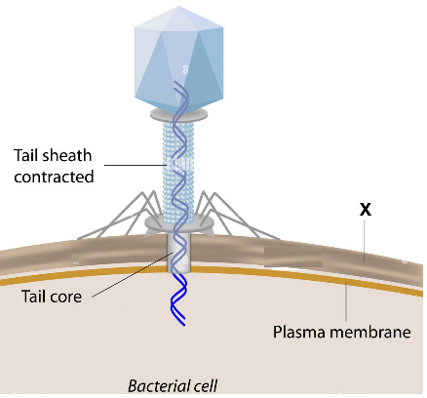
What does X represent in the given diagram?
A. Cell wall
B. Protein coat
C. Capsomeres
D. Tail pins
ANSWER: A
The virus which lives in a bacterium as parasite is called:
A. Bacteria
B. Bacteriophage
C. Arthropod-borne
D. Flu virus
ANSWER: B
_________ is a master-slave relationship
A. Bacterial cycle
B. Lysogenic cycle
C. Lytic cycle
D. Moss cycle
ANSWER: C
___________ is a host guest relationship
A. Bacterial cycle
B. Lysogenic cycle
C. Lytic cycle
D. Moss cycle
ANSWER: B

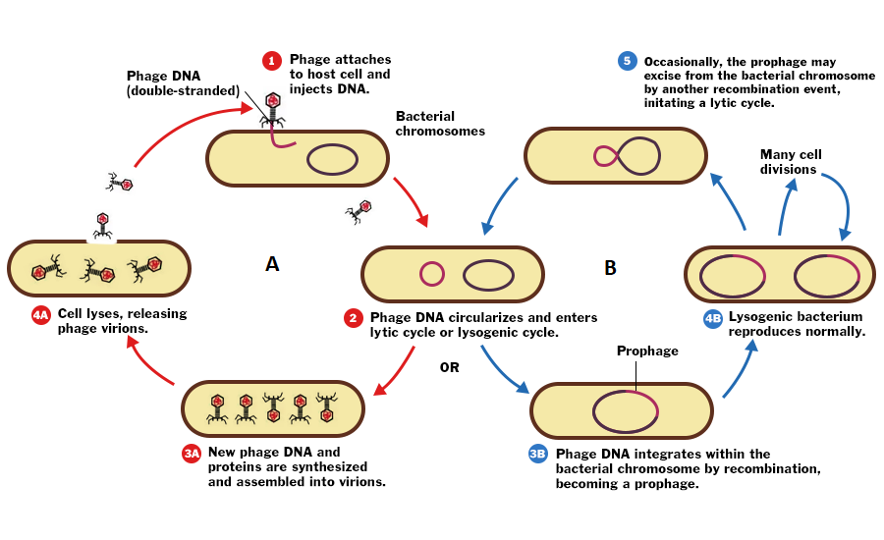
Identify the cycle A
A. Lysogenic cycle
B. Crab cycle
C. Lytic cycle
D. None of these
ANSWER: C

Identify the cycle B
A. Lysogenic cycle
B. Crab cycle
C. Lytic cycle
D. None of these
ANSWER: A

